Ravan Muradzada

Task 1
- In my network at home, private ips do not start with `172`, they are just `192.168`. So before starting the process, I want to redesign network settings for me:
I will try to switch to:
Static IP: 192.168.88.11
Netmask: 255.255.255.0
Default Gateway: 192.168.88.1
Primary DNS Server: 8.8.8.8
DNS Search Path: example.com
Hostname stays the same as `server.example.com`.

Changing a hostname is very easy and I prefer to do it with the command of: `hostnamectl set-hostname <HOSTNAME_NAME>.
If we run `hostname` command, we can see our current hostname.
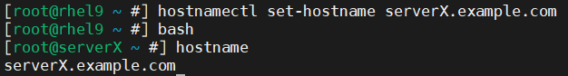

I created a new virtual adapter to set the other settings. To create a new virtual adapter, we go to VMWare Workstation Pro and right click to our virtual machine and click Settings. Then we added New Network Adapter. When we restart the virtual machine, it will be available. To see all available adapters with their configuration, we use `ip a` command:
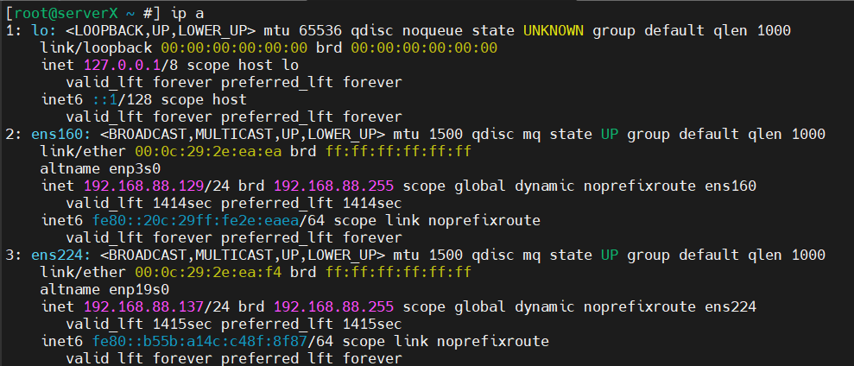
Here, `ens224` is our new adapter and it has default private ip which is given by DHCP. Now we will change it.
We write `nmtui` command and select `Edit Connection`. I can see that:
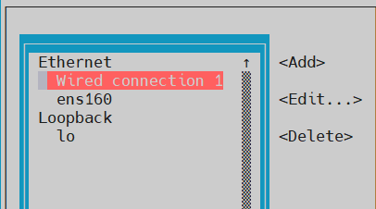
Here, `Wired Connection` is our new adapter. We need to select it and click `Edit` button.

Now in the opening page, I have changed or added some settings:
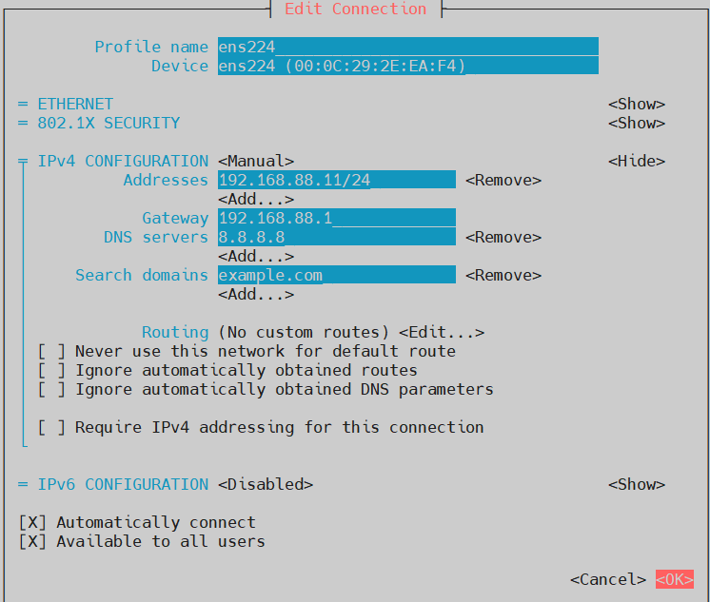
What did I change here?
- First, I updated device name to `ens224` from `Wired Connection`.
- I changed IPv4 Config from Automatic to Manual (to disable DHCP).
- I have given this address: ` 192.168.88.11/24`.
- I have given this gateway: ` 192.168.88.1`.
- I have given this DNS server: `8.8.8.8`.
- I have given this search domain: `example.com`
- I have disabled IPv6, because I do not want to see when I run `ip a`.

Now I need to click Ok. Then I deactivate and then reactivate the adapter.
Now, when I run `ip a`, I will see:
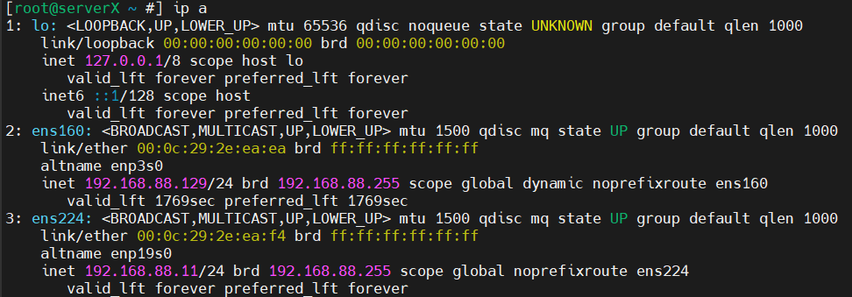
As you can see, the private ip for `ens224` has changed properly!
We can see gateway has changed too:
For DNS:
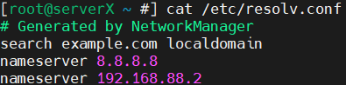

Task 2
- We go to VMWare Workstation Pro and right click the VM and select Settings. Here we add a new network adapter. Then select Bridged.
- We need to type `ip a` command to see all adapters and their config info:
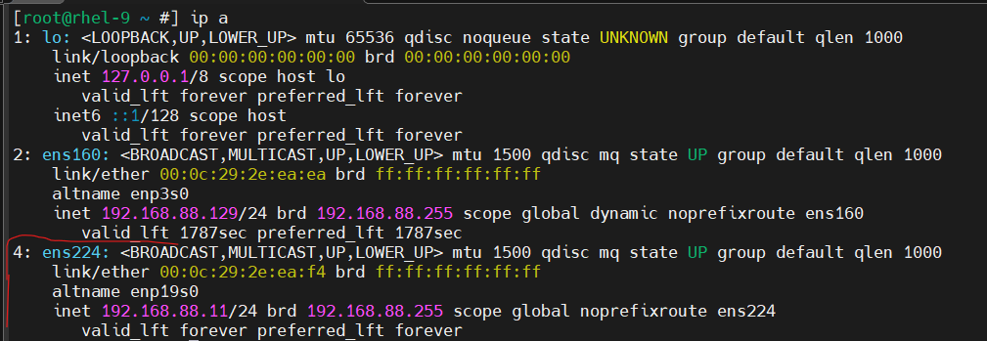
Here `ens224` is our new network adapter. It has already a private ip.

If we want to dive into logs, we can use `dmesg | grep -i ‘ens224’` command:
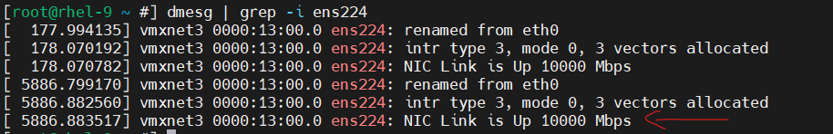

- When we run `nmcli device status`, we can see all available virtual network adapters and whether they are connected or disconnected. To connect to a virtual network adapter, we use `nmcli device connect <ADAPTER_NAME>`. To disconnect, we use `nmcli device disconnect <ADAPTER_NAME>`.
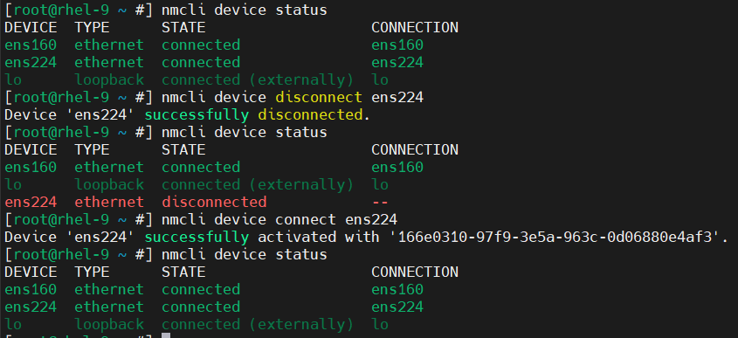
As you can see, connecting and disconnecting processes have been done successfully. After both I have run `nmcli device status` and everything is ok and our new virtual network adapter is here.

- I prefer to use `nmtui` command. We type `nmtui`, then go `Edit Connection`, select our new adapter (which is ens224) and from right we press `Edit`.
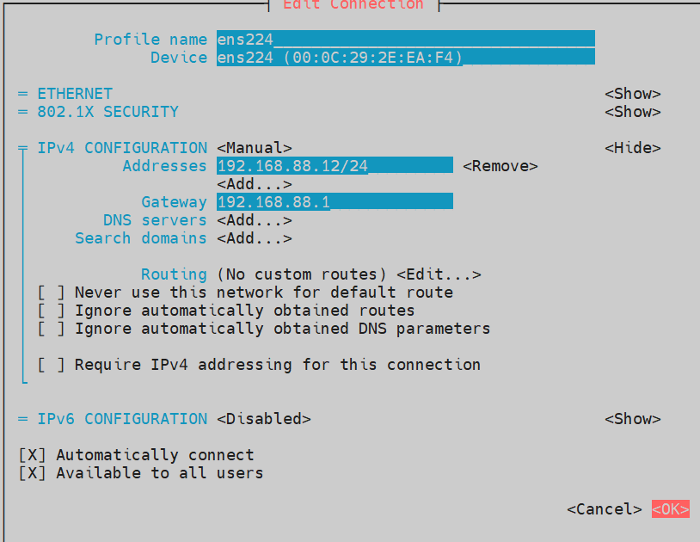
As you can see, I gave it a new private IP address, gateway IP, DNS server and Search Domain. I disabled IPv6 and make IPv4 manual.

- As you can see above, I tick `Automatically connect` option. That ensures our adapter connects to network when it reboots.
- As you can see above, my default gateway is `192.168.88.1`. Let’s ping it:
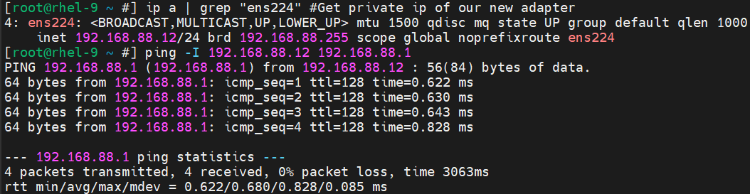
I have used `ping -I` command, so here `-I` option forces Linux to send the ping from specified IP. I specified our new adapter’s private ip.
As you can see, pinging is successful.

- The file you mention is `/etc/resolv.conf`.
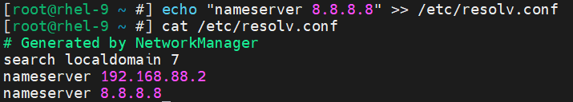
- I have found two main tools to resolve: nslookup and dig.
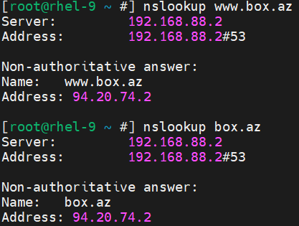

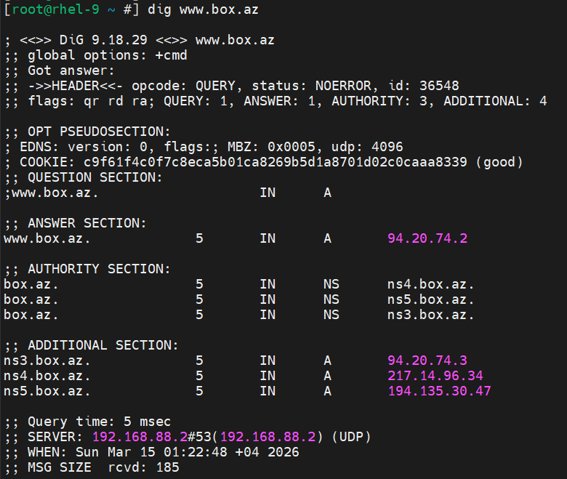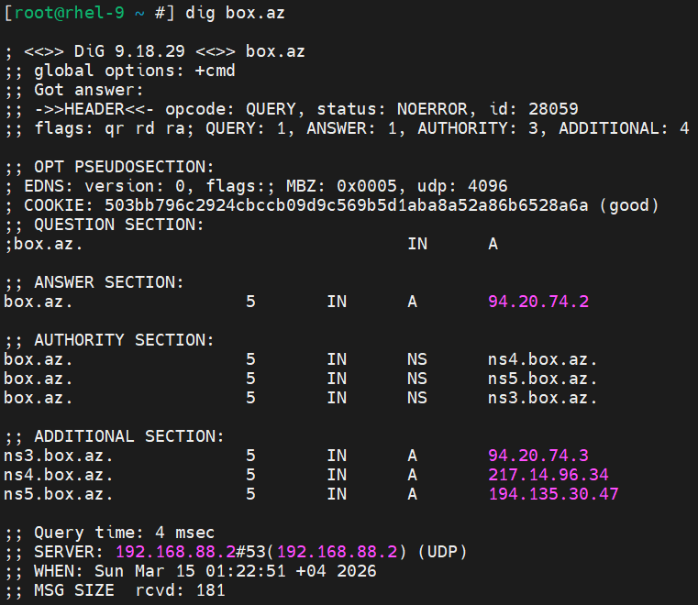

- To deactivate or activate an interface, we use `nmcli connection down <NAME>` and `nmcli connection up <NAME>`.
I have opened two ssh terminals, from the first one I deactivate and activate `ens224` interface. I used `journalctl -f` command in the second one to see real time logs.
First terminal:
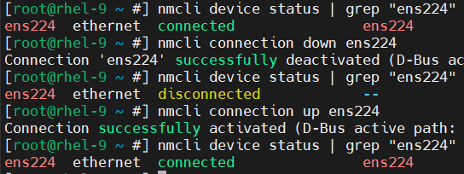

Second terminal:
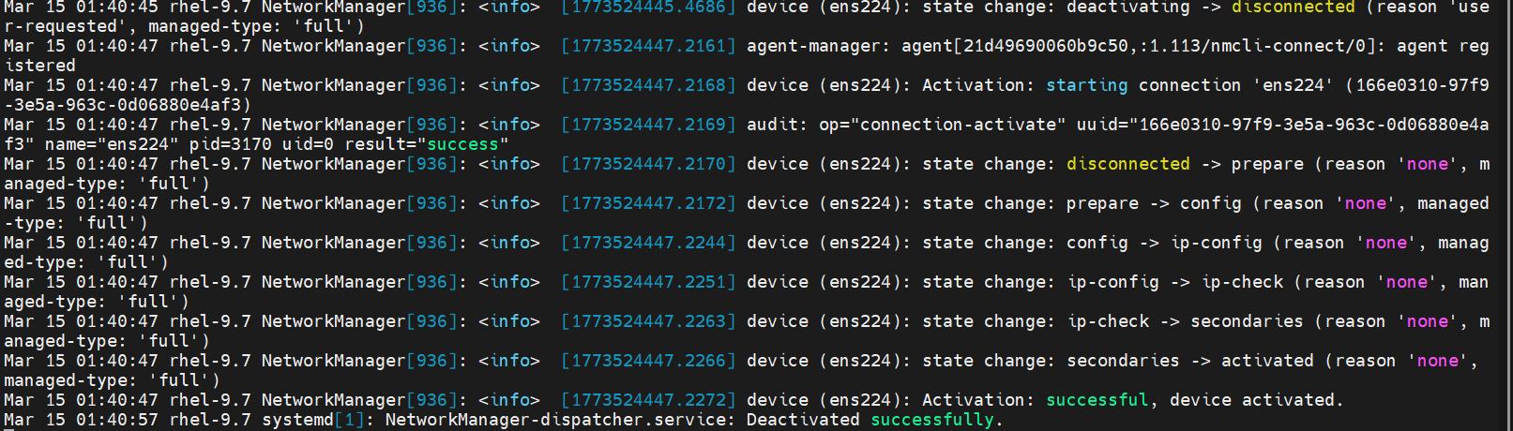

- 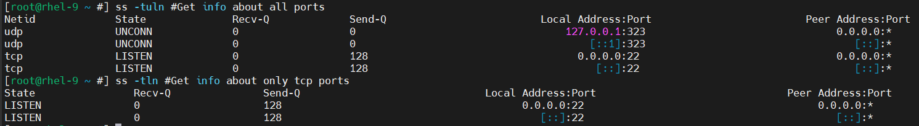

- We need to run this command: `ip route add 8.8.8.8/32 via <OUR_ROUTE_IP>`.

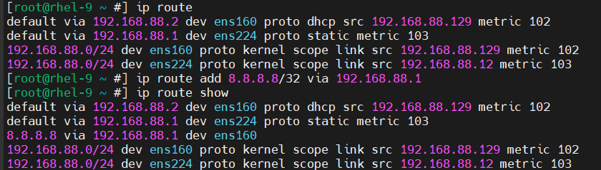

- 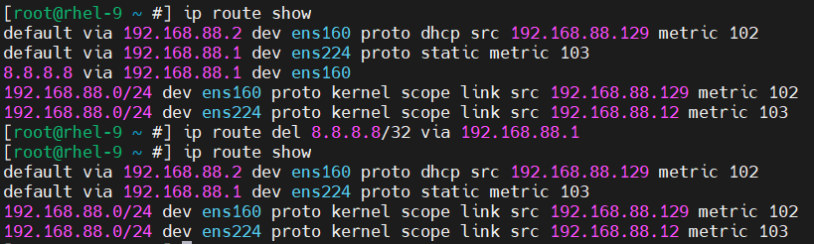
To show route table we use either `ip route` or `ip route show` commands.
To delete a route from a route table we use `ip route del 8.8.8.8/32 via <OUR_ROUTE_IP>`.

- To add new interfaces, we need to go VMWare Workstation Pro, right click our VM, select Settings and add new network adapters. We add two new network adapters.
- If we want interfaces not to have ip addresses, we need to go nmtui and disable both IPv4 and IPv6 there. Then we deactivate and activate both. Now if we run `ip a` command, we will see neither of them has ip.
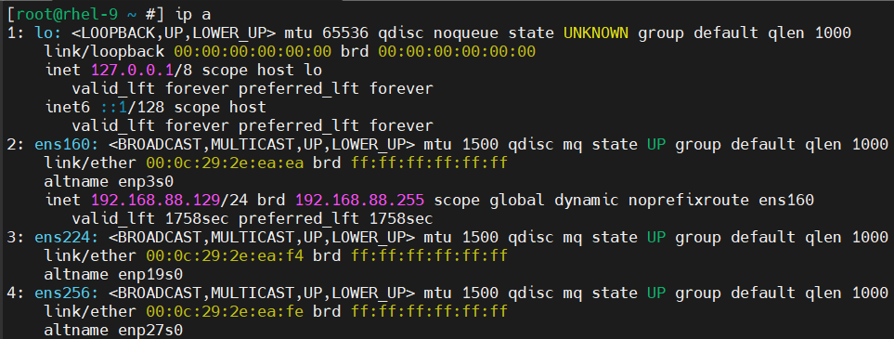
The last two represent new interfaces and they do not have ip addresses.

- Let’s look at all connections in the system: 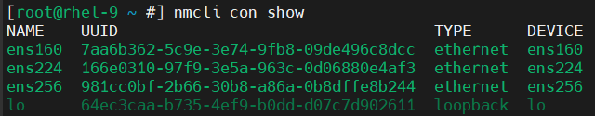
Here `ens224` and `ens256` are our new interfaces.
- Then create a team:
- Then add new interfaces to the team:
- Now let’s make both team and team members up:
- Now let’s check connections again: 